Initials

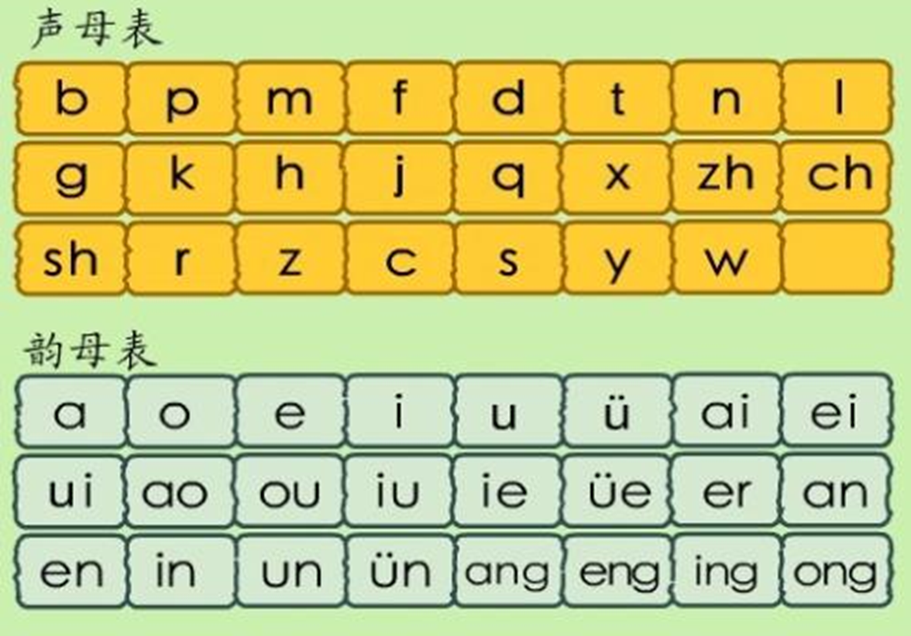

Finals



ia, ian, uai, ua, uo, uan, üan, iong